**PaintToolMvvm Prototype**

This is a prototype showing a ContourViewModel that exposes a contour as a PathGeometry property, that is then bound to a ContourView’s Polygon on the view side to render the contour

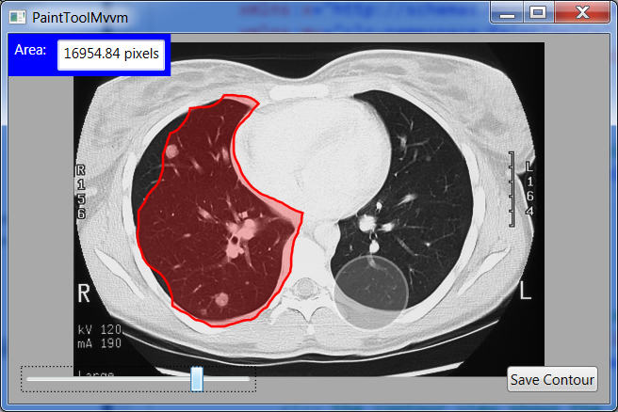

This is a class diagram of the relevant classes:

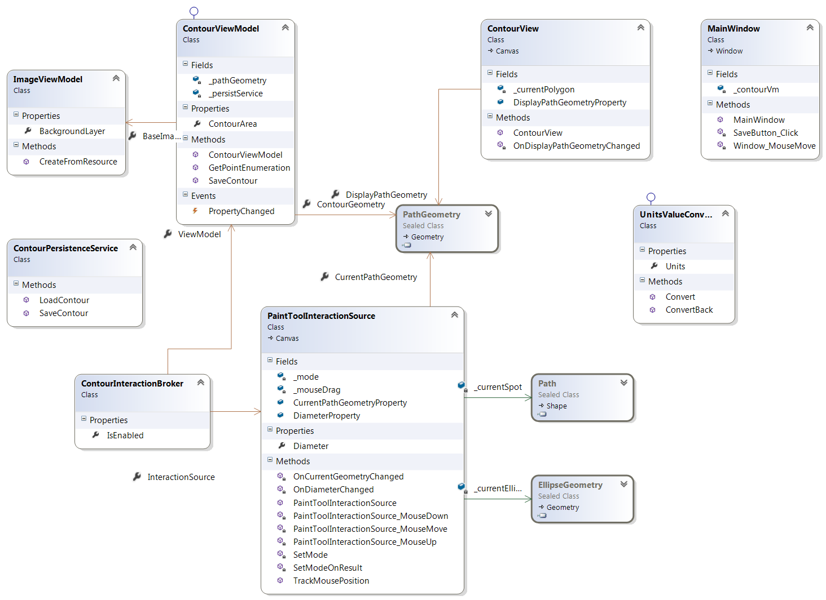

* It uses a ContourInteractionBroker to connect them (which is basically programmatic binding, instead of XAML binding)
* A PaintToolInteractionSource is responsible for updating the polygon geometry as the user paints (which is another View-type class, though it only has an ellipse as its visible extent)
* As the polygon geometry is updated, both the ContourView and the ContourViewModel are updated.
* Updation of the ContourViewModel causes the Area text box to be updated with the current polygon area.
* The PaintToolInteractionSource has a radius property that is bound to the slider, to change the radius of the paint tool
* Clicking the SaveContour invokes the ContourPersistenceService, which just dumps the points to the diagnostic output